Detecting pharmaceutical innovations in news article using ML

Team: Quinton Neville & Raghav Sawhney (DSPG)
Devika Nair, Gizem Korkmaz & Neil Kattampallil (SDAD)
Introduction:
- Innovation is the introduction of a new product or process, or an improvement made to an existing product or process that produces a significant impact or change to the market/consumers. It is important to measure innovation since it is directly related to the welfare and growth of the economy. Innovation is traditionally measured through the Business R&D and Innovation Survey (BRDIS) which measures the innovation incidence, i.e., the number of innovating firms. However, the NCSES is interested in exploring the possibility of leveraging non-traditional data to richer and complementary innovation measures.
- For our purpose, we use the Oslo manual definition for product innovation which requires that a product is either new or significantly improved or is available in the market. Our goal is to develop machine learning methods to detect mentions of product innovations in news articles while our focus is on the pharmaceutical industry since it is heavily regulated by the Food and Drug Administration (FDA) and the data is publicly available.

Data:
- We obtained 2 million articles between related to the pharmaceutical industry between 2013 and 2018 from the Dow Jones database which contained 33 variables including publisher names, title, subject codes, company codes and publication timestamps. For computation purposes, we save our data in 5 different text files for each publication year. We also discard all articles that have less than 10 words or more than 2000 words in their body.
- We conduct our analysis for all articles published in 2015 primarily because we have a separate database with all FDA records for that year. We can see the top publishers and companies in the two plots below. It is interesting to note that the top 3 mentioned companies in our articles are federal and financial entities which are followed by actual pharmaceutical companies.
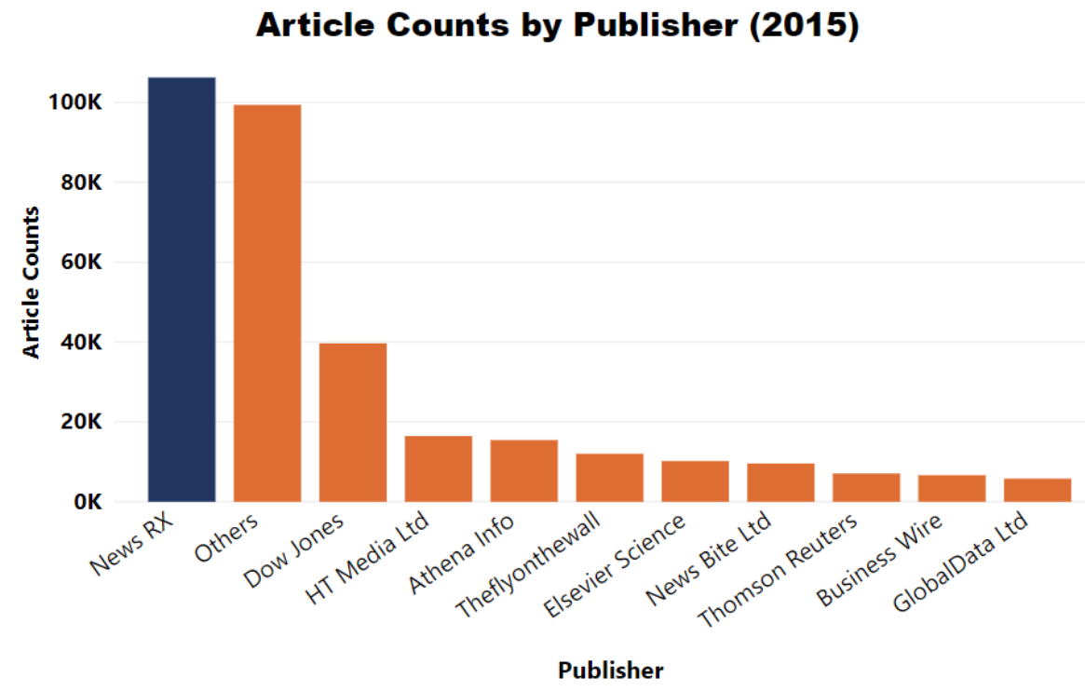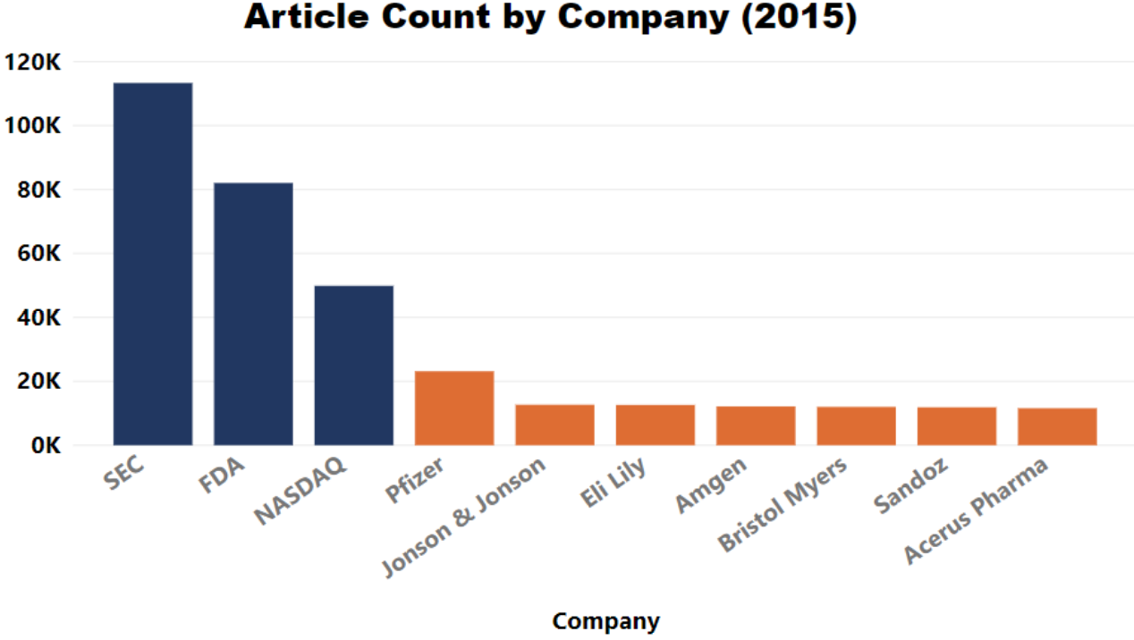
Figure 1 Figure 2

Methods:
- Our top priority was to create a labelled test set containing articles classified as either a product launch or not. Each article had a set of subject codes which depend on the content of the article. We were interested in exploring and validating articles with the ‘c22’ subject code tag which according to the DNA database indicated an article mentioning a new product launch. We applied the following query on the body text and title of all articles to filter out articles based on keywords-
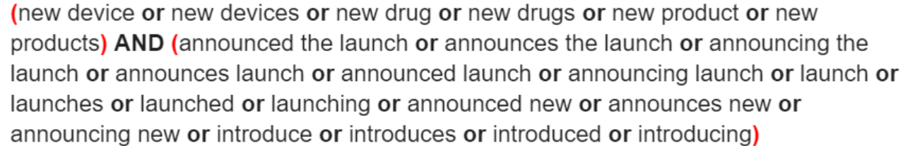

Out of the 328,606 articles we have a total of 20,593 articles which contain the ‘c22’ tag. However only 6,342 articles get filtered using our query indicating that the DNA ‘c22’ tag can not be used as a reliable label/tag for our purpose.
This led to our next step of organizing a manual labeling task which helped us label x articles where the labeler was required to mention if the article mentioned a product launch and if so what stage of FDA approval the product is in as well as the company and product names.

- Our research steps and machine learning models are explained below-
  - Text processing using Bag of Words (BoW): Creating a document-term matrix with word frequencies.
  - Feature selection to reduce dimension: Least Absolute Shrinkage and Selection Operator (LASSO) applied to our Penalized-Generalized Linear Model (P-GLM), Random Forest Model (RF) and the Gradient Boosting Methods (GBM).
  - Model training using two labeling methods: o
- M1: Manual labeling of 433 articles. Contains 137 (31.6%) articles mentioning new or improved drugs or devices. A total of 49 (11.3%) of these articles’ products were available on the market
- M2: Using DNA-generated subject code label for “New Products or Services” (c22 label tag) to create random sample of 1,000 articles (50% with the c22 label).
  - Determining cut-off probability thresholds using cost-optimization (using false-negative averse weights).
  - Performance evaluation with metrics: ROC, accuracy, precision, recall and bootstrapped out-of-bag evaluation.

Results:
The table below displays our model with description as well as their performance-
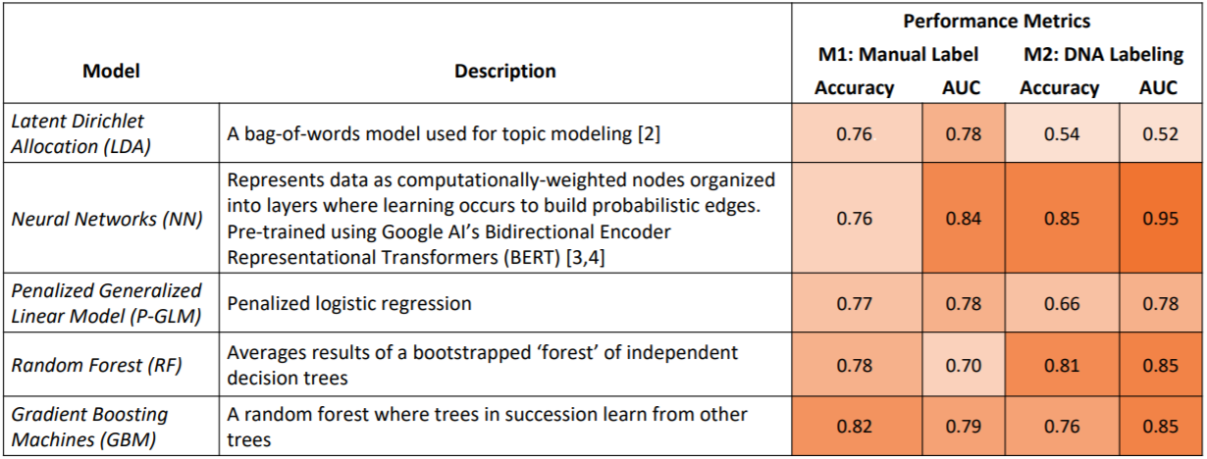
Table 1

The performance metrics reflect the false-negative averse cost-optimization of the models. The results here show the greatest accuracy with Random Forests and Gradient Boosting Method (GBM). While Neural Networks (NN) and GBM have the greatest AUC, the GBM is the better performing method as its precision-recall measures show that it captures the most true-positives while omitting the most-false negatives. Neural networks also show great promise given its inflection point in the ROC curve. NN and GBM may prove successful predictive models for the purpose of our project. Figure 3 below shows the ROC curves for our fitted supervised model while Figure 4 shows the cost-optimized bootstrap validation for our models.
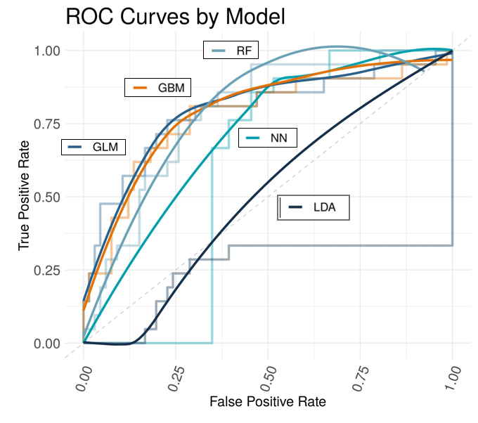 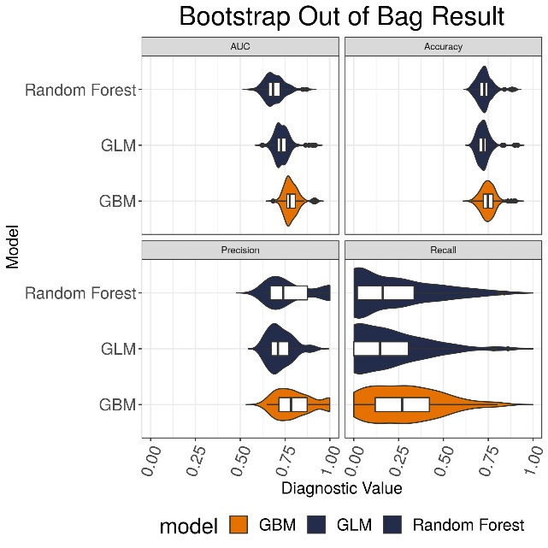
Figure 3 Figure 4

We notice models using manual labeling result in high accuracy. However, these models have low recall values due to the low proportion of innovation articles in the training set resulting in low predicted probabilities of innovation articles.

Next Steps:
- Comparing the findings (number of innovations per company) to FDA approval records.
- Expanding and implementing our models to other less regulated and less data rich industries.
- Further investigate and test the Bidirectional Encoder Representations from Transformers (BERT) pretrained neural network algorithm.
- Detecting company and product names in innovation articles.

